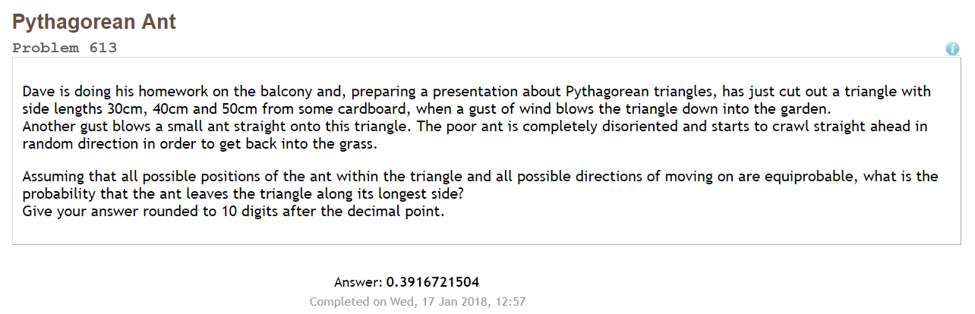Project Euler #613 – Pen & Paper Solution

First observe that for a given point (x,y) in the triangle, the probability that the ant (standing at that point) leaves the triangle along its longest side equals to the ratio between the angle ∠3 and 2π.

(3,0)

(0,4)

(x,y)

∠1

∠2

∠3

Next, we see that:



Now:



We need to find:



We will calculate each part by itself:



Part 1:



Part 2:

Part 3: 

And we get as total:

Using wolfram-alpha we get: [0.3916721504](http://www.wolframalpha.com/input/?i=1%2F2+%2B+(16ln4+-+25ln5+%2B+9ln3)%2F(24*pi))